**[Your Organization’s Letterhead]**

**Date: [Insert Date]**

**To: [Resident’s Name or Address]**

**Subject: Notice of confirmed** **galvanized requiring replacement service line (that is or was downstream of a lead service line)**

Dear [Resident’s Name],

We are writing to inform you of an important matter concerning the water service lines in your area. As part of our ongoing efforts to ensure the safety and quality of the drinking water supply, we have recently completed a survey of service lines within our community.

### **<Insert PWS name>** is focused on protecting the health of every household in our community. This notice contains important information about your drinking water. Please share this information with anyone who drinks and/or cooks using water at this property. In addition to people directly served at this property, this can include people in apartments, nursing homes, schools, businesses, as well as parents served by childcare at this property.**<Insert PWS name>** has determined that **<a portion or the entire>** water pipe (called a service line) that connects your **<home, building or other structure>** to the water main is made from **galvanized material** and may have absorbed lead**.** EPA has defined these service lines as “galvanized requiring replacement”. Our records either indicate that lead service line pipe may be present or might have been present in the past. If you have information that could help us better describe your service line, contact us at **<contact via phone, email and/or visit website >**, and we will **<add detail>.**

Galvanized service lines that have absorbed lead can contribute to lead in drinking water. People living in homes with a galvanized service line that has absorbed lead may have an increased risk of exposure to lead from their drinking water. **<Consider adding language based on situational knowledge, such as: The galvanized service line at this location is/was/may have been connected to a lead service line prior to <date> or is downstream of an unknown service line which may contain lead.>** 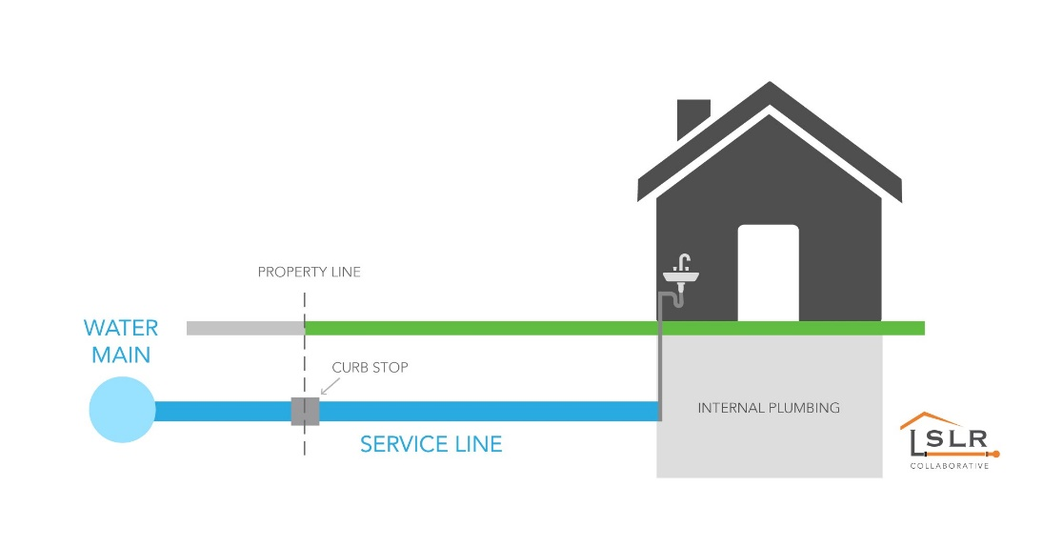

## Health effects of lead

*Exposure to lead in drinking water can cause serious health effects in all age groups. Infants and children can have decreases in IQ and attention span. Lead exposure can lead to new learning and behavior problems or worsen existing learning and behavior problems. The children of women who are exposed to lead before or during pregnancy can have increased risk of these negative health effects. Adults can have increased risks of heart disease, high blood pressure, and kidney, or nervous system problems.*

## Steps you can take to reduce lead in drinking water.

Below are recommended actions that you may take, separately or in combination, if you are concerned about lead in your drinking water. The list also includes where you may find more information and is not intended to be a complete list or to imply that all actions equally reduce lead in drinking water.

**Use filters properly**. Using a filter can reduce lead in drinking water. If you use a filter, it should be certified to remove lead. Read any directions provided with the filter to learn how to properly install, maintain, and use your cartridge and when to replace it. Using the cartridge after it has expired can make it less effective at removing lead. Do not run hot water through the filter. For more information on facts and advice on home water filtration systems, EPA has developed a <https://www.epa.gov/water-research/consumer-tool-identifying-point-use-and-pitcher-filters-certified-reduce-lead>.

**Clean your aerator.** Regularly clean your faucet’s screen (also known as an aerator). Sediment, debris, and lead particles can collect in your aerator. If lead particles are caught in the aerator, lead can get into your water.

**Use cold water**. Do not use hot water from the tap for drinking, cooking, or making baby formula as lead dissolves more easily into hot water. Boiling water does not remove lead from water.

**<Areas prone to drought or currently experiencing scarcity of water may want to omit or edit this recommendation.> Run your water.** The more time water has been sitting in pipes providing water to your home, the more lead it may contain. Before drinking, flush your home’s pipes by running the tap, taking a shower, doing laundry, or doing a load of dishes. The amount of time to run the water will depend on whether your home has a lead service line or not, as well as the length and diameter of the service line and the amount of plumbing in your home. [Include tailored flushing information, if appropriate, or add following language] Residents may contact us at [phone number and/or email address] for recommendations about flushing times in their community.

**Learn about construction in your neighborhood.** Contact us at [phone number and/or email address] to find out about any construction or maintenance work that could disturb your service line. Construction may cause more lead to be released from a lead service line or galvanized service line if present.

**Have your water tested.** Contact us, your water utility, at **<insert PWS contact information – phone, email, etc.>** to have your water tested and to learn more about the lead levels in your drinking water. Alternatively, you may contact a certified laboratory to have your water tested for lead. A list of certified

laboratories are available at **<provide location of list> or <explain your water system’s testing program and any costs to customer if one exists>.** Note, a water sample may not adequately capture or

represent all sources of lead that may be present**.** For information on sources of lead that include service lines and interior plumbing, please visit <https://www.epa.gov/ground-water-and-drinking-water/basic-information-about-lead-drinking-water#getinto>.

## Get your child tested to determine lead levels in their blood.

A family doctor or pediatrician can perform a blood test for lead and provide information about the health effects of lead. State, city, or county departments of health can also provide information about how you can have your child's blood tested for lead. The Centers for Disease Control and Prevention recommends public health actions when the level of lead in a child’s blood is 3.5 micrograms per deciliter (µg/dL) or more. Please visit <https://www.cdc.gov/nceh/lead/advisory/acclpp/actions-blls.htm> for information on these actions.

## Replacing galvanized requiring replacement service lines

**<Insert information about your water system’s lead service line replacement program, if applicable, or other opportunities to replace lead service lines.>**

If you are planning on replacing the portion of the service line that you own, please notify us at **<insert PWS contact information – phone, email, etc.>.**

### **For information about potential financing solutions** to assist property owners with replacement of lead service lines, please contact us at **<insert PWS contact information – phone, email, etc.>.**

### **For more information on reducing lead exposure** from your drinking water and the health effects of lead, visit EPA’s website at [*http://www.epa.gov/lead*](http://www.epa.gov/lead)